CS 305 Module Two Coding Assignment Template

Instructions
Replace the bracketed text with the relevant information in your own words. If you choose to include images or supporting materials, make certain to insert them in all the relevant locations in the document.

Run Dependency Check

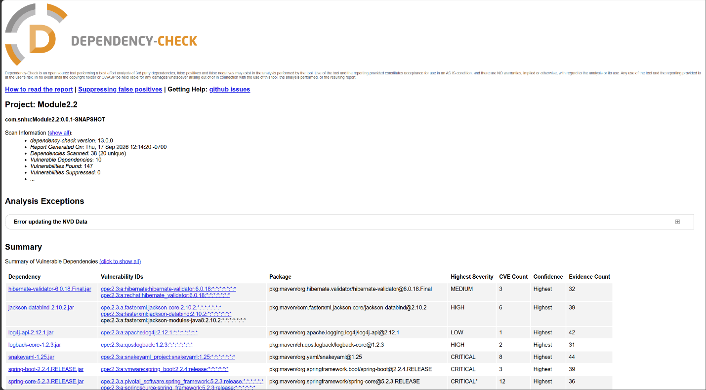

The Dependency-Check scan found 38 dependencies, which include 20 unique ones. Of these, 10 dependencies are vulnerable, resulting in 147 reported vulnerabilities. These vulnerabilities range from Low to Critical severity. The dependencies with the most vulnerabilities are tomcat-embed-websocket-9.0.30.jar (50), tomcat-embed-core-9.0.30.jar (49), spring-web-5.2.3.RELEASE.jar (13), and spring-core-5.2.3.RELEASE.jar (12 CVEs).

hibernate-validator-6.0.18.Final.jar:
- Dependency: org.hibernate.validator:hibernate-validator:6.0.18.Final
- Concern: Several known security problems related to Expression Language (EL) processing, input validation, HTML injection, and potential cross-site scripting (XSS).
- CVEs listed: CVE-2025-35036, CVE-2023-1932, and CVE-2020-10693.
- Severity: CVE-2025-35036 is rated HIGH; CVE-2023-1932 and CVE-2020-10693 are MEDIUM.
- Update Hibernate Validator to a new version that fixes these vulnerabilities and works well with Spring Boot and Bean Validation. This dependency comes with Spring Boot; it is better to update the Spring Boot dependency management instead of just replacing the JAR file.
jackson-databind-2.10.2.jar:
- Dependency: com.fasterxml.jackson.core:jackson-databind:2.10.2
- Concern: Multiple known security vulnerabilities, including denial-of-service/resource-exhaustion issues and an XXE-related issue.
- Most relevant CVEs listed: CVE-2020-25649, CVE-2020-36518, CVE-2021-46877, CVE-2022-42003, CVE-2022-42004, and CVE-2023-35116.
- Severity: HIGH.
- Upgrade Jackson Databind to a supported, patched version that is compatible with the application's Spring Boot version.
log4j-api-2.12.1.jar:
- Dependency: org.apache.logging.log4j:log4j-api:2.12.1
- Concern: A vulnerability exists in the Log4j SMTP appender due to improper certificate validation. This flaw may allow a man-in-the-middle attacker to intercept an SMTPS connection, potentially granting access to log messages transmitted through the appender.
- CVEs listed: CVE-2020-9488
- Severity: LOW
- Upgrade Log4j to a version containing the security fix. For CVE-2020-9488, the vulnerability was fixed in Log4j 2.12.3 and 2.13.1.
logback-core-1.2.3.jar:
- Dependency: ch.qos.logback:logback-core:1.2.3
- Concern: Security risks related to unsafe deserialization and harmful Logback configuration. These issues could lead to denial-of-service attacks or, in some cases, allow attackers to run arbitrary code.
- CVEs listed: CVE-2023-6378 and CVE-2021-42550.
- Severity: CVE-2023-6378 is rated HIGH; CVE-2021-42550 is rated MEDIUM.
- Upgrade Logback to a patched version. The Dependency-Check report identifies versions before 1.2.13 as affected by CVE-2023-6378 and versions through 1.2.7 as affected by CVE-2021-42550.
snakeyaml-1.25.jar:
- Dependency: org.yaml:snakeyaml:1.25
- Concern: Unsafe YAML files present several known issues. These problems can lead to denial-of-service attacks, stack overflows, or resource exhaustion when processing untrusted YAML input. The most critical concern is that it could allow remote code execution on the affected system.
- CVEs listed: CVE-2022-1471, CVE-2017-18640, CVE-2022-25857, CVE-2022-38749, CVE-2022-38751, CVE-2022-38752, CVE-2022-41854, and CVE-2022-38750.
- Severity: CVE-2022-1471 is rated CRITICAL. CVE-2017-18640 and CVE-2022-25857 are rated HIGH. CVE-2022-38749, CVE-2022-38751, CVE-2022-38752, CVE-2022-41854, and CVE-2022-38750 are rated MEDIUM .
- Upgrade SnakeYAML to version 2.0 or later due to known security issues in version 1.25, including CVE-2022-1471. Use a safe constructor when handling untrusted YAML, and restrict type deserialization.
spring-boot-2.2.4.RELEASE.jar:
- Dependency: org.springframework.boot:spring-boot:2.2.4.RELEASE
- Concern: The version of Spring Boot in use is outdated and has several known security vulnerabilities, including security bypass, temporary directory hijacking, and denial-of-service issues.
- CVEs listed: CVE-2023-20873, CVE-2022-27772, and CVE-2023-20883.
- Severity: CVE-2023-20873 is CRITICAL, CVE-2022-27772 is HIGH, and CVE-2023-20883 is HIGH.
- Upgrade Spring Boot from version 2.2.4.RELEASE to a newer, supported version. This change matters because Spring Boot manages many related software packages. Upgrading can also fix security issues in components like Jackson, Hibernate Validator, and Log4j.
spring-core-5.2.3.RELEASE.jar:
- Dependency: org.springframework:spring-core:5.2.3.RELEASE
- Concern: The Spring Framework version is old and has several known security issues. These include risks such as remote code execution, denial of service, privilege escalation, log injection, open redirects, and server-side request forgery.
- CVEs listed: CVE-2022-22965, CVE-2024-22259, CVE-2021-22118, CVE-2020-5421, CVE-2022-22950, CVE-2022-22971, CVE-2023-20861, CVE-2023-20863, CVE-2022-22968, CVE-2022-22970, CVE-2021-22060, and CVE-2021-22096.
- Severity: CVE-2022-22965 is rated CRITICAL. CVE-2024-22259 and CVE-2021-22118 are rated HIGH. The remaining listed vulnerabilities range from MEDIUM to HIGH.
- Upgrade Spring Framework or Spring Boot to a currently supported, patched version. Because spring-core is part of the Spring Boot dependency hierarchy, it's important to fix CVE-2022-22965. The likelihood of exploitation depends on how the application is set up, including whether it uses Spring MVC/WebFlux and certain deployment conditions.
spring-web-5.2.3.RELEASE.jar:
- Dependency: org.springframework:spring-web:5.2.3.RELEASE
- Concern: The outdated Spring Web version contains multiple security vulnerabilities, including remote code execution and denial of service.
- CVEs listed: CVE-2016-1000027, CVE-2022-22965, CVE-2024-22259, CVE-2021-22118, CVE-2020-5421, CVE-2022-22950, CVE-2022-22971, CVE-2023-20861, CVE-2023-20863, CVE-2022-22968, CVE-2022-22970, CVE-2021-22060, and CVE-2021-22096.
- Severity: CVE-2016-1000027 and CVE-2022-22965 are rated CRITICAL. CVE-2024-22259 and CVE-2021-22118 are rated HIGH. The remaining vulnerabilities listed are rated MEDIUM.
- Update Spring Framework and Spring Boot to the latest supported versions with security patches. CVE-2022-22965 is a critical remote code execution vulnerability, and CISA lists it as a known exploited vulnerability. The Spring4Shell attack relies on how the application is set up and deployed.
tomcat-embed-core-9.0.30.jar:
- Dependency: org.apache.tomcat.embed:tomcat-embed-core:9.0.30
- Concern: The Tomcat version is outdated and has several security risks, including remote code execution, authentication bypass, and path traversal issues.
- CVEs listed: A total of 49
- Severity: Vulnerabilities are CRITICAL and HIGH
- Upgrade Tomcat to a supported version. Since tomcat-embed-core is included via spring-boot-starter-web, do not manually replace the Tomcat JAR; instead, update the Spring Boot dependency management. To address vulnerabilities such as CVE-2020-1938, use Tomcat version 9.0.31 or higher. For CVE-2024-50379, use version 9.0.98 or higher. For CVE-2025-24813, use version 9.0.99 or higher. Choose a supported combination of Spring Boot and Tomcat to avoid older fixes.
tomcat-embed-websocket-9.0.30.jar:
- Dependency: org.apache.tomcat.embed:tomcat-embed-websocket:9.0.30
- Concern: The Tomcat version is outdated and has multiple known security vulnerabilities, including remote code execution, authentication bypass, and improper privilege/security management.
- CVEs listed: Total of 50
- Severity: CRITICAL
- Upgrade the embedded Tomcat dependency to a supported, patched version. Exploiting CVE-2020-1938 requires an exposed AJP connector. It is still a good idea to upgrade Tomcat to fix other vulnerabilities as well.

